Title | Analog Input Software Subsystem Design Description
Distribution | Software Archive
Author | Spring Zhou  Jax Yang | Date | 2014-01-06
Review | See review section | Date | See review section
Approved |  | Date
Remarks

Contents

1 Context 3
1.1 Introduction 3
1.2 Definitions, acronyms, and abbreviations 3
2 Data Sheet 3
3 Detailed Description 5
3.1 Static Modelling 5
3.1.1 Hardware interface 5
3.1.2 Use case 5
3.2 Dynamic Modelling 6
3.3 Class Design 7
3.4 Detailed Design 7
3.4.1 Initialization 7
3.4.2 Get AD converter value 8
3.4.3 Public interface object 9
3.4.4 Diagnosis 9
3.4.5 Data Simulation 9
3.5 Design Decisions and Limitations 10
3.6 Hardware Dependencies 10
3.6.1 Raw value 10
3.6.2 Low power consumption design 10
4 References 10
5 Revision History 10
6 Design Review 10
6.1 Decision of the Review: 11
6.2 Check list: 11
6.3 Remarks: 11
6.4 Defects 11
6.5 Changes are proved: 12

List of Figures

Figure 1 ADS1146 PIN diagram 5
Figure 2 Use case 6
Figure 3 Analog Input data process dynamic diagram 6
Figure 4 Analog input class diagram 7
Figure 5 Initialization of the Analog input diagram 8
Figure 6 GetRawValue diagram 9

List of Tables
Table 1 ADS1146 pin configuration table 5
Table 2 ADS1146 registers configuration table 8
Table 3 AI Selection mode table 9
Table 4 Diagnosis information table 9
Table 5 Raw value table 10

Context

Introduction

This Document is a representation of analysis, planning, implementation and decision-making. It consists of design information for the subsystem Analog Input. One of its major goals is to support reuse of the described subsystem.

The document is divided into two main parts. First there is the data sheet in chapter one. This chapter is intended for developers that want to reuse the subsystem. Therefore it lists important issues from a black-box view. The second chapter describes the design in more detail. This is the right place to look for developers who have to maintain or expand the subsystem.

Besides this document there are other documents that describe the requirements, test cases and the complete system the subsystem is used in. Links to those documents can be found at the end of the data sheet.

Definitions, acronyms, and abbreviations
Term  AI  HMI subsystem  Hart subsystem  MVMeasurement subsystem  Coordinator subsystem  IO Board  Code generation tools  Framework  SSRS | Definition  Analog Input  A subsystem handle with the communication with HMI Board  A subsystem handle with the Hart communication with other devices  A subsystem which will use analog input value for calculation  A subsystem handle with the task process, system management  A hardware system which handle with 4~20mA current to voltage converting, AD converting, and digital outputting.  Some software tools distributed with the Framework, it includes EntryTool.exe, HMIGen.exe, and etc.  The framework used for all measurement project, it contains the code genrate tools and a code base for the basic data types.  Subsystem software requirement specification

Data Sheet
This chapter gives an overview about all important facts of the subsystem. It can be used by a developer who would like to reuse this subsystem.

Category | Item | Description
Development | Version / Status | 1.0.1
Development | Known Bugs | None
Development | Planned Improvements | None
HW-Platform | Type | M16CR5F363AM
HW-Platform | Clocking | System Clocking — 3.684MHz
SW-Development Environment | Compiler | IAR for M16C, V3.4
SW-Development Environment | Operating System | Segger embOS for M16C version 3.28g
SW-Development Environment | Case / Code-Generation Tool | EntryTool 1.1.3
Required Resources | Operating System | Semaphore: mapperDataSemaphore
Required Resources | HW | 2Wire CB  IO board
Required Resources | RAM | 110 Byte
Required Resources | NVRAM | 9 Byte
Required Resources | ROM | 4302 Byte
Required Resources | Execution Time
Required Resources | Special HW | No
Required Resources | Subsystems | - HART  - HMI  - Coordinator  - Mapper
Required Resources | Data Objects | - SIMPLE_U8  - FLOAT  - SIMPLE_FLOAT  - TABENUM8
Standards | Safety | No
Standards | Other | None
Documentation | Requirements / Use Cases | Please refer to Figure 1 Use case
Documentation | Public Interface Description | Please refer to 3.4 Design details
Documentation | Test Specification | Please refer to [TP007]AI Software Subsystem Test Plan

Detailed Description

Static Modelling

Hardware interface
ADS1146 is used to sample the signal which is converted from 4~20mA by amplifier circuit. The MCU M16C63 connect to the AD converter on IO board with S4/IO and get the AD convert value of the 4-20mA via SPI. The pin diagram is shown in Figure 2 ADS1146 PIN diagram.

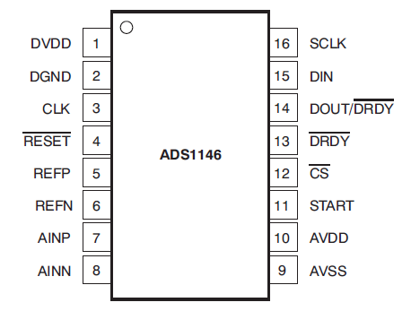
Figure 2 ADS1146 PIN diagram

The pin configuration is listed as the table below:
Pin NO. | Name | Pin of MCU Connected together | Description
3 | SCK | P9_5/CLK4 | SPI clock
4 | RESET | P10_0 | The reset signal of ADS1146
14 | DOUT | P9_7/SIN4 | Serial data output to MCU
15 | DIN | P9_6/SOUT4 | Serial data input to ADS1146
Table 1 ADS1146 pin configuration table

The detailed information about ADS1146 is described in the specification of ADS1146.( TI-ADS1146.pdf).

Use case

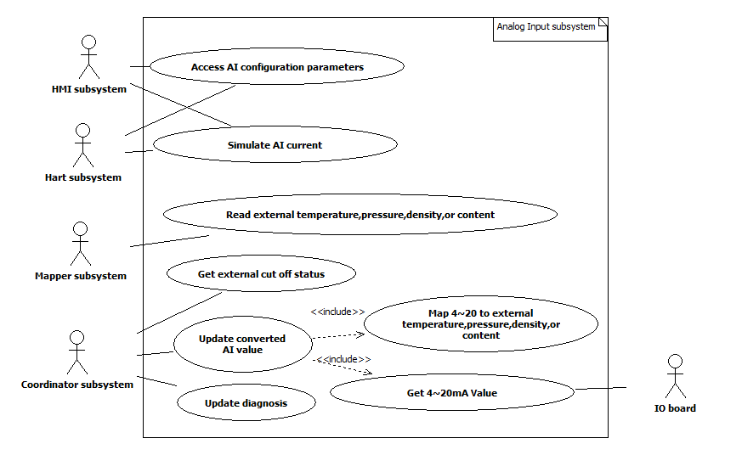
Figure 3 Use case

Dynamic Modelling

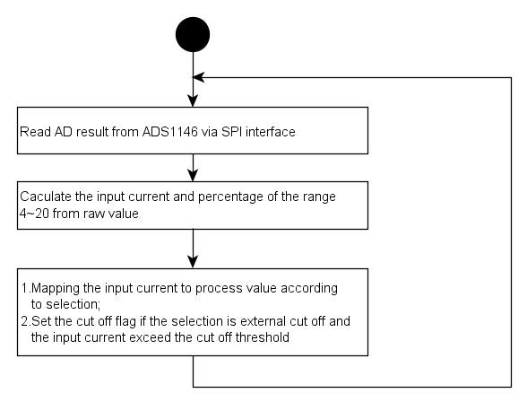
Figure 4 Analog Input data process dynamic diagram

Class Design
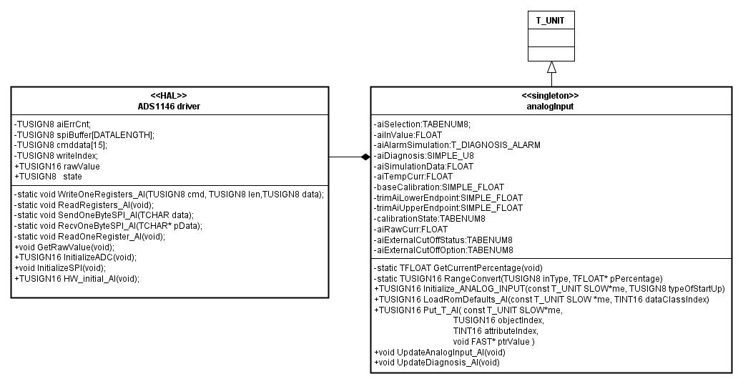
Figure 5 Class diagram

Detailed Design

Initialization
In the initialization, the analog input subsystem configure the SPI controller at first then configure the ADS1146 using WriteRegisters() function. The configuration of the AD register refers to TI-ADS1146.pdf.
Then read the configuration using ReadRegisters() function to check if the communication is ok.
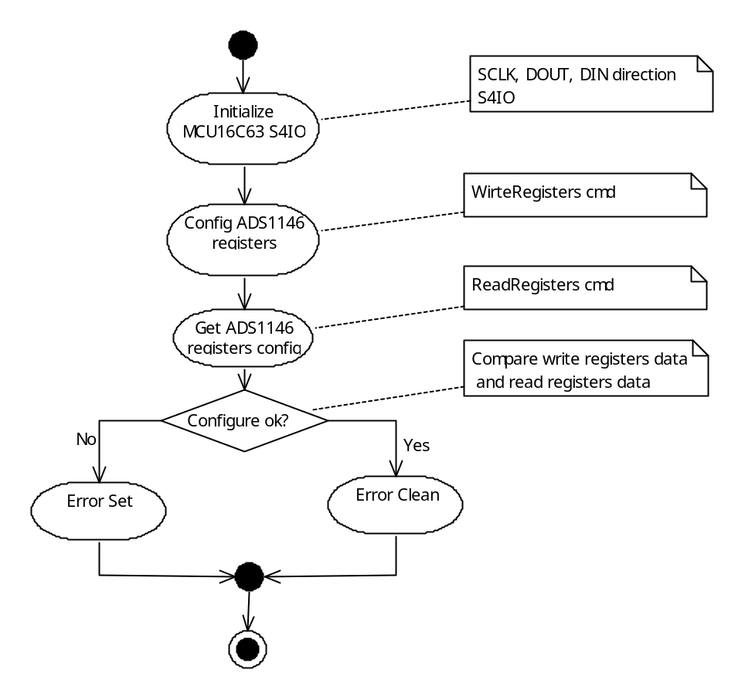
Figure 6 Initialization of the Analog input diagram

The registers configuration is listed below.
ADS1146 registers | Value | Meaning
BCS | 0x01 | Burnout current source off
ID | 0x08 | DOUT/DRDY pin functions both as Data Out and Data Ready, active low
Table 2 ADS1146 registers configuration table

Get AD converter value
For low power consumption hardware design, the circuit make the DIN pin voltage level reverse, then the normal level is low. After get the Raw value from the ADS1146, we should make the DIN pin at the voltage low level. So we add a register read command to get ID register value. The value of ID is 0x88, so the last bit is always zero.

Due to the DOUT signal of ADS1146 is inverted by IO board, subsystem bitwise the result read from ADS1146. The formula is showed as below:
Raw value = 0x7fff – (~result);

Result is the 16 bits value read from ADS1146 via SPI interface.
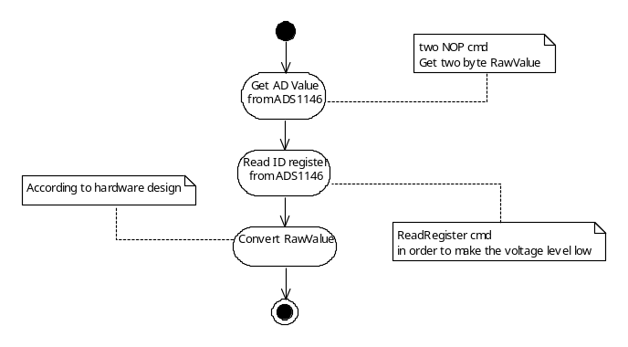
Figure 7 GetRawValue diagram

Public interface object
aiSelection : TABENUM8 ,provide the system analogue input mode.
item | description
AI_TEMPERATURE | Temperature input
AI_PRESSURE | Pressure input
AI_PRESSURE_ABS | Absolute pressure input
AI_DENSITY | Density input
AI_GAS_CONTENT | Gas content input
AI_CUTOFF | Cut off the device output if the current input exceed the cut off threshold
AI_WITHOUT | No input

Table 3 AI Selection mode table

aiInValue : FLOAT, provide the analogue input value in base unit according to the selection.

Diagnosis
Analog input provides 3 alarms listed below.
Marco | Value | description
ERR_SPICOM_FAIL | 0x01 | SPI communication error
ERR_OUT_OF_RANGE | 0x02 | The input current is out of the range 3.8~20.5 mA
ERR_CUT_OFF | 0x04 | The output is cut off
Table 4 Diagnosis information table

The UpdateDiagnosis() function is used to update the diagnosis and maintain subsystem diagnosis information.

Data Simulation
When analog input subsystem checked that the simulation mode is set as analog data simulation, it will put the value of aiSimulationData to the aiValue instead of field value.

Design Decisions and Limitations

Hardware Dependencies

Raw value

0~25mA current input signal should be linearly transformed into 0~2.048V, just showed as the table below:
descriptor | Current | Voltage | Raw value
RAWADMAX | 25mA | 2.048V | 0x7fff
RAWADMIN | 0mA | 0V | 0x0
RAWADHILIM | 22.6mA | 1.8532V | 0x73d0
RAWADLOLIM | 3.5mA | 0.287V | 0x11f0
RAWADHIRNG | 20mA | 1.640V | 0x6680
RAWADLORNG | 4mA | 0.328V | 0x1480
Table 5 Raw value table

Low power consumption design
In order to save the power consumption, the SPI DIN signal is isolated by photoelectric couplers, that means the ADS1146 have an independent power supply.

References
Ref. | Document
[1] | RS006-Analog Input Software Subsystem Requirements Specification
[2]
[3]
[4]

Revision History
Rev. | Description of Version/Changes | Primary Author(s) | Date
0.1 | Initial revision. | Spring Kunli.Zhou  Jax Yang | 2012-05-28
0.2 | Modify this document base on new requirements | Jax Yang | 2013-05-30
0.3 | Modify the document based on Vincent/Spring review | Jax Yang | 2013-06-19
0.4 | Update section 2 | Jax Yang | 2014-01-06

Design Review

Dept. | Name
R&D ShangHai | Spring Zhou, Vincent Liu | 2013-06-17 rev0.2

Dept. | Name
R&D ShangHai | Spring Zhou, Vincent Liu | 2013-06-19 rev0.3

Dept. | Name
R&D ShangHai | Merrick Huang | 2014-01-06 rev0.4

Decision of the Review:
 | Decision | next steps
 | Inspection passed without restrictions | Phase finished
Y | Inspection passed with restrictions | some changes must be done
 | Inspection not passed | Inspection must be repeated

Check list:
 |  | yes | no
1. | Is the software architecture distinct and documented? | Y
2. | Fit the modules together? | Y
3. | Are complex algorithms/procedures explained? | Y
4. | Is a strategy for error handling designated? | Y
5. | Is the configuration management system well prepared? | Y
6. | Are all open issues transferred to the defects table? | Y

Remarks:

Defects
No. | Checkpoint | Description | Major defect | Done Date
1 | 3.4.1 | Replace the section title Initialize with Initialization | N | 2013-6-17
2 | Figure 5 | Redraw the initialization diagram:  - Modify the notes  - Use diamond-shaped box as decision test | N | 2013-6-17
3 | 3.4.2 | Spell error: replace an with a. | N | 2013-6-17
4 | 3.4.3 | Specify the object type for aiSelection, aiInValue | N | 2013-6-17
5 | 3.4.4 | “four diagnosis…” shall be “four alarms…” | N | 2013-6-17
6 | 3.6.2 | Spell error: replace a with an. | N | 2013-6-17
7 | 3.4.4 | There are only 3 alarms in this subsystem | N | 2013-6-19
8 |  | Modify the datasheet according to latest design | N | 2014-1-06
9 |  | Delete the reference documents M16C63 - Hardware manual.pdf, TI-ADS1146.pdf | N | 2014-1-06

Changes are proved:
The Reviewer confirms that all changes are done:
Proved Rev: | Date: | Reviewer:
0.3 | 2013-06-19 | Spring Zhou Vincent Liu
0.4 | 2014-01-06 | Merrick Huang

